Attendance Management System :

- Introduction:-

Attendance Management System is software developed for daily student attendance in schools, colleges and institutes. If facilitates to access the attendance information of a particular Employee in a particular industry. The information is sorted by the operators, which will be provided by the employee for a particular working day. This system wills also help in evaluating attendance eligibility criteria of a employee.

Purpose:-

The purpose of developing attendance management system is to computerized the tradition way of taking attendance. Another purpose for developing this software is to generate the report automatically at the end of the session or in the between of the session.

Scope:-

The scope of the project is the system on which the software is installed, i.e. the project is developed as a desktop application, and it will work for a particular institute or organization. But later on the project can be modified to operate it online.

Employee Profile:-

Employee Personal information: Name, Lastname, Contact, address, Email, Contact no, Select Type.
- 4.3 Feasibility Study:

A key part of the preliminary investigation that reviews anticipated costs and benefits and recommends a course of action based on operational, technical, economic, and time factors. The purpose of the study is to determine if the systems request should proceed further.

- Economically Feasibility:

The system being developed is economic with respect to Business or point of view. It is cost effective in the sense that has eliminated the salary work completely. The system is also time effective because the calculations are automated which are made at the end of the month or as per the employee requirement. The result obtained contains minimum errors and are highly accurate as the data is required.

- Technical feasibility:

The technical requirement for the system is economic and it does not use any other additional Hardware and software.

- Behavioral Feasibility:

The system working is quite easy to use and learn due to its simple but attractive interface. user requires no special training for operating the system.

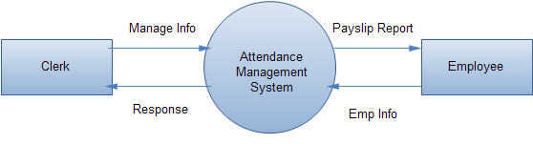
DATA FLOW DIAGRAM (Level 1)

Njn
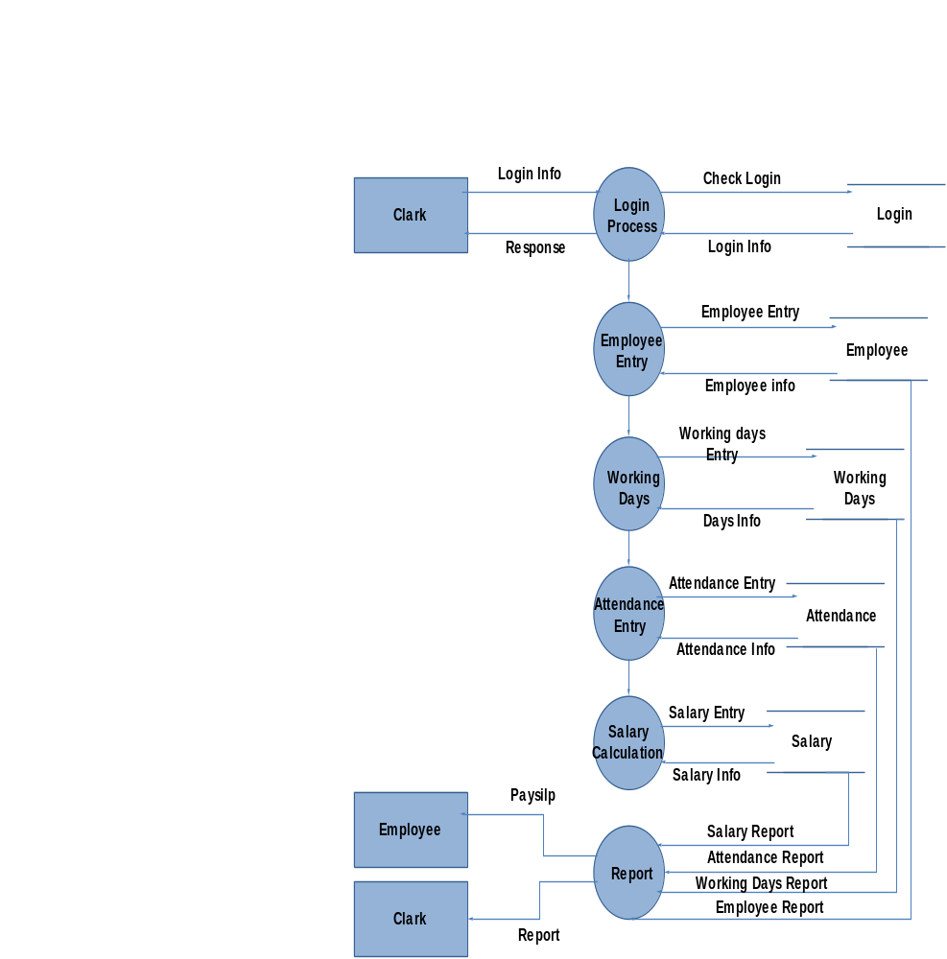APP
WELCOME PAGE

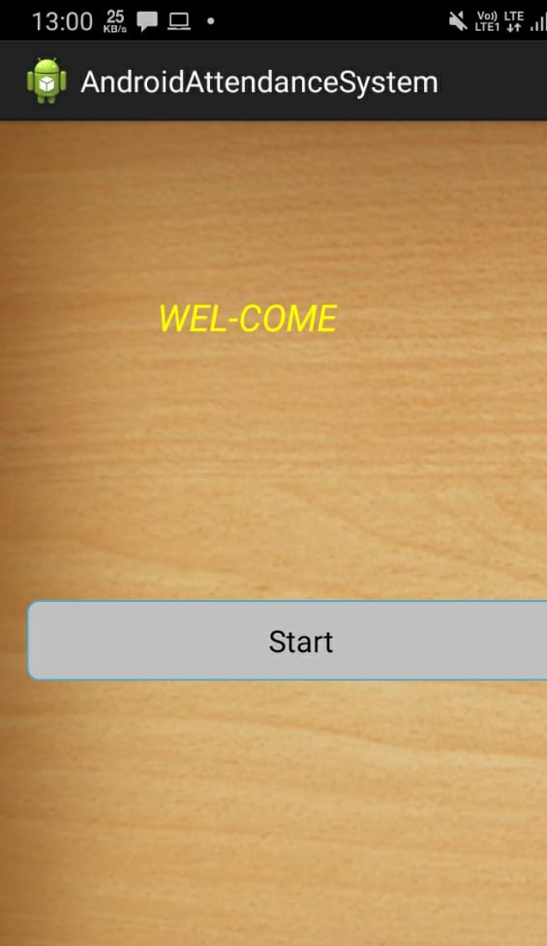
ADMIN LOGIN PAGE:
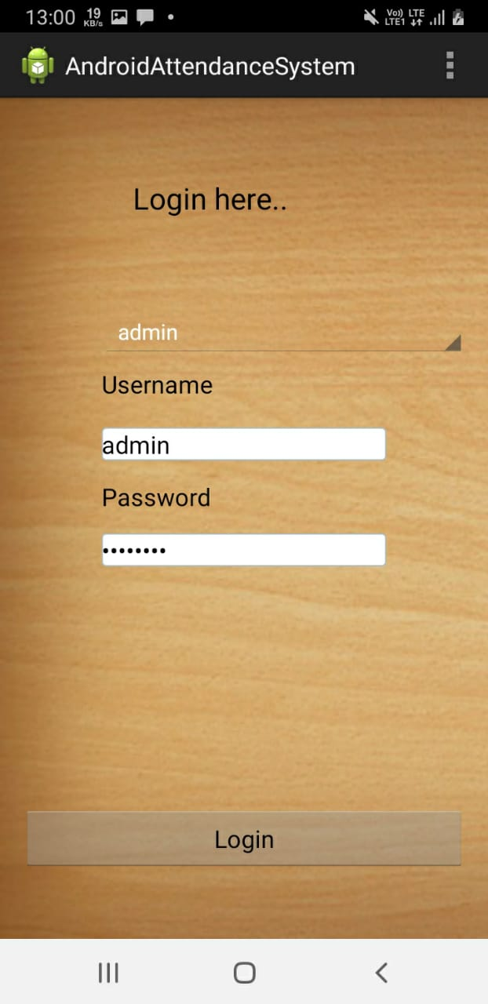
SELECTED MEMBER
